THIRD GRADE MATHEMATICS
UNIT 1 STANDARDS
Dear Parents,
As we shift to Common Core Standards, we want to make sure that you have an understanding of the mathematics your child will be learning this year. Below you will find the standards we will be learning in Unit One. Each standard is in bold print and underlined and below it is an explanation with student examples. Your child is not learning math the way we did when we were in school, so hopefully this will assist you when you help your child at home. Please let your teacher know if you have any questions ☺

MCC.3.NBT.1 Use place value understanding to round whole numbers to the nearest 10 or 100.
This standard refers to place value understanding, which extends beyond an algorithm or procedure for rounding. The expectation is that students have a deep understanding of place value and number sense and can explain and reason about the answers they get when they round. Students should have numerous experiences using a number line and a hundreds chart as tools to support their work with rounding.

For example:
Question: Round 34 to the nearest ten.
Student thinking: Let me locate 34 on a number line. I know that it takes four jumps (ones) to get back to 30 and six jumps (ones) to get to 40. This means that the closest ten would be 30.

30 34 40

MCC.3.NBT.2 Fluently add and subtract within 1000 using strategies and algorithms based on place value, properties of operations, and/or the relationship between addition and subtraction.
This standard refers to fluently, which means accuracy, efficiency (using a reasonable amount of steps and time), and flexibility (using strategies such as the distributive property). The word algorithm refers to a procedure or a series of steps. There are other algorithms other than the standard algorithm. Third grade students should have experiences beyond the standard algorithm. A variety of algorithms will be assessed.
Example: There are 178 fourth graders and 225 fifth graders on the playground. What is the total number of students on the playground?
Student 1  100 + 200 = 300  70 + 20 = 90  8 + 5 = 13  300+90+13 = 403 students |  | Student 2  I added 2 to 178 to get 180. I added 220 to get 400. I added the 3 left over to get 403. |  | Student 3  I know 75 plus 25 equals 100. Then I added 1 hundred from 178 and 2 hundreds from 275. I had a total of 4 hundreds and I had 3 more left to add. So I have 4 hundreds plus 3 more which is 403.

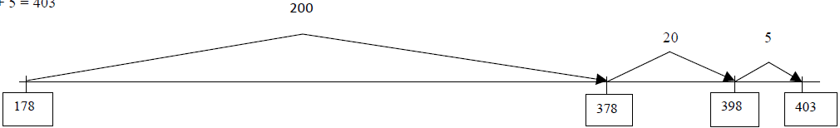
Student 4

178 + 225 = ?
178 + 200 = 378
378 + 20 = 398

398 + 5 = 403

MCC.3.NBT.3 Multiply one-digit whole numbers by multiples of 10 in the range 10–90 (e.g., 9 × 80, 5 × 60) using strategies based on place value and properties of operations.

This standard expects that students go beyond tricks that hinder understanding such as “just adding zeros” and explain and reason about their products. For example, for the problem 50 x 4, students should think of this as 4 groups of 5 tens or 20 tens. Twenty tens equals 200.

MCC.3.MD.3 Draw a scaled picture graph and a scaled bar graph to represent a data set with several categories. Solve one- and two-step “how many more” and “how many less” problems using information presented in scaled bar graphs. For example, draw a bar graph in which each square in the bar graph might represent 5 pets.
Students should have opportunities reading and solving problems using scaled graphs before being asked to draw one. The following graphs all use five as the scale interval, but students should experience different intervals to further develop their understanding of scale graphs and number facts. While exploring data concepts, students should Pose a question, Collect data, Analyze data, and Interpret data (PCAI). Students should be graphing data that is relevant to their lives
Example:
Pose a question: Student should come up with a question. What is the typical genre read in our class?
Collect and organize data: student survey
Pictographs: Scaled pictographs include symbols that represent multiple units. Below is an example of a pictograph with symbols that represent multiple units. Graphs should include a title, categories, category label, key, and data. How many more books did Juan read than Nancy?

Number of Books Read
Nancy | 
Juan
 | = 5 books
Single Bar Graphs: Students use both horizontal and vertical bar graphs. Bar graphs include a title, scale, scale label, categories, category label, and data.
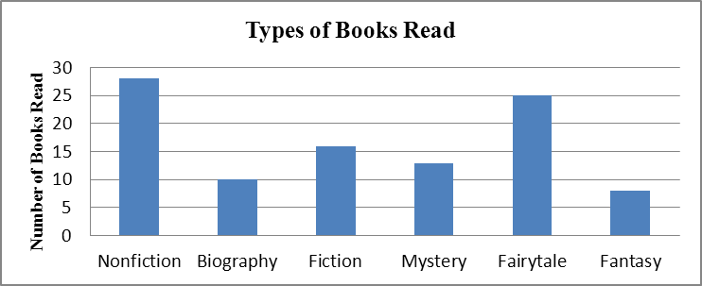

Analyze and Interpret data:
- How many more nonfiction books where read than fantasy books?
- Did more people read biography and mystery books or fiction and fantasy books?
- About how many books in all genres were read?
- Using the data from the graphs, what type of book was read more often than a mystery but less often than a fairytale?
- What interval was used for this scale?
- What can we say about types of books read? What is a typical type of book read?
- If you were to purchase a book for the class library which would be the best genre? Why?

MCC.3.MD.4 Generate measurement data by measuring lengths using rulers marked with halves and fourths of an inch. Show the data by making a line plot, where the horizontal scale is marked off in appropriate units – whole numbers, halves, or quarters.
Students in second grade measured length in whole units using both metric and U.S. customary systems. It is important to review with students how to read and use a standard ruler including details about halves and quarter marks on the ruler. Students should connect their understanding of fractions to measuring to one-half and one-quarter inch. Third graders need many opportunities measuring the length of various objects in their environment. This standard provides a context for students to work with fractions by measuring objects to a quarter of an inch. Example: Measure objects in your desk to the nearest ½ or ¼ of an inch, display data collected on a line plot. How many objects measured ¼? ½? etc. …

